Assignment Activity
Renae Harewood
Information Technology, University of the People
MSIT 5910-01 Capstone Project
Dinesh Kumar Dharamdasani
April 19, 2026

- Defining the Problem Statement
Problem Context
The rapid adoption of cloud-based platforms has transformed how organizations manage communication, collaboration, and data storage. Solutions such as Microsoft 365 are widely used by small and mid-sized businesses (SMBs) due to their scalability, accessibility, and cost-effectiveness. However, despite these advantages, many SMBs lack structured governance and security frameworks to manage these environments effectively.
This problem falls within the domains of cloud computing and cybersecurity, where misconfigurations, weak identity management, and lack of monitoring significantly increase organizational risk. Research shows that cloud misconfigurations and poor access controls are among the leading causes of data breaches (Alharbi & Atkins, 2021). Additionally, organizations often fail to utilize built-in security tools, leaving systems exposed to threats such as phishing, unauthorized access, and data leakage (Behl & Behl, 2022).
Without centralized governance, administrative tasks such as user provisioning, access control, and compliance monitoring are handled inconsistently. This results in limited visibility, inefficient operations, and increased vulnerability to cyber threats.
Stakeholders
The primary stakeholders affected by this problem include:
- IT Administrators: Responsible for managing users, security configurations, and system monitoring. Lack of automation increases workload and risk of human error.
- Business Management: Faces financial and reputational risks associated with data breaches or operational disruptions.
- End Users (Employees): Depend on secure and reliable systems for daily operations; security failures can disrupt productivity.
- Customers/Clients: Their data may be exposed if proper safeguards are not in place, impacting trust and compliance.
- Regulatory Bodies: Organizations must comply with data protection regulations, and failure to do so may result in penalties.
Solving this problem will improve operational efficiency, strengthen security posture, and enhance trust across stakeholders.
Problem Statement
Small and mid-sized businesses using Microsoft 365 lack a centralized governance and security monitoring framework, resulting in inconsistent system configurations, limited visibility into user activity, and increased exposure to cybersecurity threats. This gap leads to operational inefficiencies, compliance risks, and potential data breaches, highlighting the need for a structured, automated, and scalable governance solution.
- Project Scope, Goals, and Expected Outcomes
Project Scope
This project focuses on the design and partial implementation of a Cloud Governance and Security Monitoring Framework within a Microsoft 365 environment. The scope includes:
- Configuring security controls such as multifactor authentication (MFA) and role-based access control (RBAC)
- Implementing audit logging and monitoring features
- Developing PowerShell automation scripts for user and license management
- Creating a centralized dashboard for monitoring system activity and compliance
Exclusions:
- Full enterprise deployment
- Integration with third-party security platforms
- Advanced AI-based threat detection systems
Assumptions and Constraints:
- Access to a Microsoft 365 environment for testing
- Limited timeframe (8 weeks)
- Use of built-in tools to minimize cost
Project Goals
- Specific: Design and implement a governance framework that improves visibility and security within a Microsoft 365 environment.
- Measurable: Achieve at least a 50% reduction in manual administrative tasks through automation and implement at least three security controls (e.g., MFA, RBAC, audit logging).
- Achievable: Utilize existing Microsoft 365 tools and PowerShell scripts within a controlled test environment.
- Relevant: Address real-world cloud security challenges faced by SMBs.
- Time-bound: Complete design, implementation, and evaluation within the 8-week capstone timeline.
Expected Outcomes
The project will deliver the following tangible outcomes:
- A functional prototype of a cloud governance framework
- Configured security policies (MFA, RBAC, logging)
- PowerShell scripts for automation of administrative tasks
- A monitoring dashboard for real-time visibility
- Documentation including system architecture, configuration steps, and user guidelines
These outcomes will demonstrate improved operational efficiency, enhanced security posture, and reduced administrative workload.
- Ethical and Security Implications
Ethical Issues
The project involves handling sensitive organizational and user data, which raises several ethical considerations:
- Data Privacy: Ensuring that user data is protected and only accessed by authorized individuals
- User Consent: Informing users about monitoring practices and data collection
- Fair Access Control: Avoiding bias in role assignments and permissions
- Intellectual Property: Ensuring proper use of tools, scripts, and documentation
Failure to address these issues could lead to ethical violations and loss of trust.
Security Implications
The proposed system must address key cybersecurity risks, including:
- Unauthorized Access: Weak authentication mechanisms can lead to account compromise
- Data Breaches: Misconfigured permissions may expose sensitive information
- System Vulnerabilities: Lack of monitoring increases the risk of undetected threats
- Insufficient Logging: Without proper logs, incidents cannot be effectively investigated
According to the National Institute of Standards and Technology, continuous monitoring and access control are critical components of a secure system (Rose et al., 2020).
Mitigation Measures
To address these risks, the project will implement:
- Multifactor Authentication (MFA): Strengthens user authentication
- Role-Based Access Control (RBAC): Ensures least-privilege access
- Encryption: Protects data in transit and at rest
- Audit Logging: Tracks system activity for accountability
- Compliance Alignment: Follows NIST Cybersecurity Framework guidelines
These measures ensure that the solution is both secure and ethically responsible.
- Project Planning Tools
Gantt Chart
The project will follow a structured timeline divided into key phases:
Phase | Duration | Activities
Planning | Week 1–2 | Define requirements, finalize proposal
Design | Week 2–3 | Architecture design, security planning
Implementation | Week 3–5 | Configure controls, develop scripts
Testing | Week 5–6 | Validate functionality and security
Documentation | Week 6–7 | Prepare reports and deliverables
Final Submission | Week 8 | Submit project and reflection

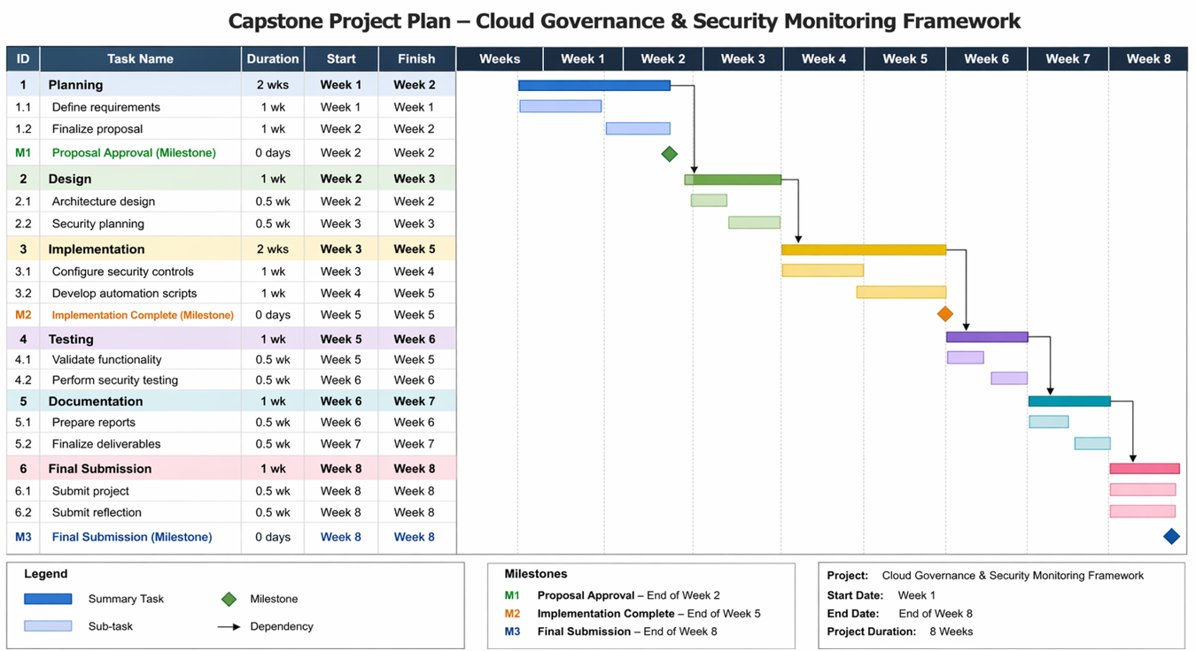
The Gantt chart provides visibility into task dependencies and ensures timely completion (Project Management Institute, 2021).
Resource Justification Table
Resource | Type | Purpose | Justification
Microsoft 365 | Software | Core platform | Required for implementation
PowerShell | Tool | Automation | Enables task efficiency
ProjectLibre | Software | Project management | Supports scheduling and tracking
Test Environment | Infrastructure | Safe testing | Prevents impact on production
Documentation Tools | Software | Reporting | Ensures clear deliverables

Feasibility Checklist
Feasibility Type | Assessment
Technical | Feasible using Microsoft 365 and scripting tools
Operational | Aligns with SMB operational needs
Economic | Low cost due to use of existing tools
Schedule | Achievable within 8 weeks
Risk | Manageable with proper planning and controls

This checklist confirms that the project is practical and achievable within defined constraints.
Conclusion
This capstone project addresses a critical gap in cloud governance and security for SMBs using Microsoft 365. By designing a structured framework that integrates automation, monitoring, and security controls, the project provides a practical and scalable solution to a real-world IT problem.
The proposal demonstrates a clear problem definition, well-defined scope, measurable goals, and tangible outcomes. Ethical and security considerations are addressed through established best practices, while project planning tools ensure effective execution.
Overall, this project aligns with MSIT Program Learning Outcomes and provides a strong foundation for implementation, demonstrating both technical expertise and practical application in IT governance and cybersecurity.

References
Alharbi, F., & Atkins, A. (2021). Cloud computing security challenges and solutions for small and medium enterprises. Journal of Cloud Computing, 10(1), 1–15. https://doi.org/10.1186/s13677-021-00232-0
Behl, A., & Behl, K. (2022). Cybersecurity and cyberwar: What everyone needs to know. Oxford University Press.
Project Management Institute. (2021). A guide to the project management body of knowledge (PMBOK® Guide) (7th ed.). PMI.
Rose, S., Borchert, O., Mitchell, S., & Connelly, S. (2020). Zero trust architecture (NIST Special Publication 800-207). National Institute of Standards and Technology. https://doi.org/10.6028/NIST.SP.800-207

